**Android Application for Native Calculator**

Aim:

        To develop a Simple Android Application for Native Calculator.

Procedure:

Creating a New project:

* Open Android Stdio and then click on **File -> New -> New project.**

[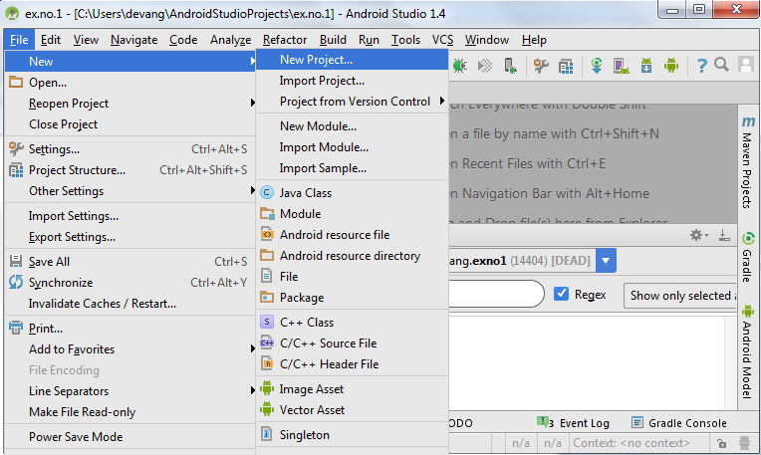](https://codingconnect.net/wp-content/uploads/2016/02/new-project.png)

* Then type the Application name as “**exno3″** and click **Next.**
* Then select the **Minimum SDK** as shown below and click **Next**.
* Then select the **Empty Activity**and click **Next.**
* Finally click F**inish**.
* It will take some time to build and load the project.
* After completion it will look as given below.

Designing layout for the Android Application:

* Click on **app -> res -> layout -> activity_main.xml.**
* Now click on **Text** as shown below.

Experiment 3

**MainActivity.java**

package com.example.exno3;  
  
import android.os.Bundle;  
  
import android.text.TextUtils;  
import android.view.View;  
import android.view.View.OnClickListener;  
import android.widget.Button;  
import android.widget.EditText;  
import android.widget.TextView;  
  
import androidx.appcompat.app.AppCompatActivity;  
  
public class MainActivity extends AppCompatActivity implements OnClickListener  
{  
 //Defining the Views  
 EditText Num1;  
 EditText Num2;  
 Button Add;  
 Button Sub;  
 Button Mul;  
 Button Div;  
 TextView Result;  
  
 @Override  
 public void onCreate(Bundle savedInstanceState)  
 {  
 super.onCreate(savedInstanceState);  
 setContentView(R.layout.*activity_main*);  
  
 //Referring the Views  
 Num1 = (EditText) findViewById(R.id.*editText1*);  
 Num2 = (EditText) findViewById(R.id.*editText2*);  
 Add = (Button) findViewById(R.id.*Add*);  
 Sub = (Button) findViewById(R.id.*Sub*);  
 Mul = (Button) findViewById(R.id.*Mul*);  
 Div = (Button) findViewById(R.id.*Div*);  
 Result = (TextView) findViewById(R.id.*textView*);  
  
 // set a listener  
 Add.setOnClickListener(this);  
 Sub.setOnClickListener(this);  
 Mul.setOnClickListener(this);  
 Div.setOnClickListener(this);  
 }  
  
 @Override  
 public void onClick (View v)  
 {  
  
 float num1 = 0;  
 float num2 = 0;  
 float result = 0;  
 String oper = "";  
  
 // check if the fields are empty  
 if (TextUtils.*isEmpty*(Num1.getText().toString()) || TextUtils.*isEmpty*(Num2.getText().toString()))  
 return;  
  
 // read EditText and fill variables with numbers  
 num1 = Float.*parseFloat*(Num1.getText().toString());  
 num2 = Float.*parseFloat*(Num2.getText().toString());  
  
 // defines the button that has been clicked and performs the corresponding operation  
 // write operation into oper, we will use it later for output  
 switch (v.getId())  
 {  
 case R.id.*Add*:  
 oper = "+";  
 result = num1 + num2;  
 break;  
 case R.id.*Sub*:  
 oper = "-";  
 result = num1 - num2;  
 break;  
 case R.id.*Mul*:  
 oper = "*";  
 result = num1 * num2;  
 break;  
 case R.id.*Div*:  
 oper = "/";  
 result = num1 / num2;  
 break;  
 default:  
 break;  
 }  
 // form the output line  
 Result.setText(num1 + " " + oper + " " + num2 + " = " + result);  
 }  
}

**activity_main.xml**

<?xml version="1.0" encoding="utf-8"?>  
<LinearLayout  
 xmlns:android="http://schemas.android.com/apk/res/android"  
 xmlns:app="http://schemas.android.com/apk/res-auto"  
 android:orientation="vertical"  
 android:layout_width="match_parent"  
 android:layout_height="match_parent"  
 android:layout_margin="20dp">  
  
 <LinearLayout  
 android:id="@+id/linearLayout1"  
 android:layout_width="match_parent"  
 android:layout_height="wrap_content"  
 android:layout_margin="20dp">  
  
 <EditText  
 android:id="@+id/editText1"  
 android:layout_width="match_parent"  
 android:layout_height="wrap_content"  
 android:layout_weight="1"  
 android:inputType="numberDecimal"  
 android:textSize="20sp" />  
  
 <EditText  
 android:id="@+id/editText2"  
 android:layout_width="match_parent"  
 android:layout_height="wrap_content"  
 android:layout_weight="1"  
 android:inputType="numberDecimal"  
 android:textSize="20sp" />  
  
 </LinearLayout>  
  
 <LinearLayout  
 android:id="@+id/linearLayout2"  
 android:layout_width="match_parent"  
 android:layout_height="wrap_content"  
 android:layout_margin="20dp">  
  
 <Button  
 android:id="@+id/Add"  
 android:layout_width="match_parent"  
 android:layout_height="wrap_content"  
 android:layout_weight="1"  
 android:text="+"  
 android:textSize="30sp"  
 app:iconTint="#2196F3" />  
  
 <Button  
 android:id="@+id/Sub"  
 android:layout_width="match_parent"  
 android:layout_height="wrap_content"  
 android:layout_weight="1"  
 android:text="-"  
 android:textSize="30sp"/>  
  
 <Button  
 android:id="@+id/Mul"  
 android:layout_width="match_parent"  
 android:layout_height="wrap_content"  
 android:layout_weight="1"  
 android:text="*"  
 android:textSize="30sp"/>  
  
 <Button  
 android:id="@+id/Div"  
 android:layout_width="match_parent"  
 android:layout_height="wrap_content"  
 android:layout_weight="1"  
 android:text="/"  
 android:textSize="30sp"/>  
  
 </LinearLayout>  
  
 <TextView  
 android:id="@+id/textView"  
 android:layout_width="match_parent"  
 android:layout_height="wrap_content"  
 android:layout_marginTop="50dp"  
 android:text="Answer is"  
 android:textSize="30sp"  
 android:gravity="center"/>  
  
</LinearLayout>

**Output-**